PROJECT REPORT
Electric Vehicle Market Performance & Insights
Data Analytics with Tableau – Capstone Project

Submitted by: Parvi Sharma
Medicaps University
Team ID: NA
November 2026

Dashboard: https://public.tableau.com/app/profile/parvi.sharma/viz/ElectricVehicleMarketPerformanceandInsights/EVMarketDashboard
Story: https://public.tableau.com/app/profile/parvi.sharma/viz/ElectricVehicleMarketPerformanceandInsights/Story1
GitHub: [Paste GitHub repository link]
Demo video: [Paste Google Drive demo video link]

1. INTRODUCTION
1.1 Project Overview
Electric vehicles are one of the fastest-growing parts of the automotive industry. Manufacturers, consultants and governments need clear information about which vehicles sell, where they sell, which battery technologies are used and how much CO₂ they save.
In this project I analysed 100,000 EV records (ev_market_test.csv, 37 attributes, model years 2018–2026) in Tableau. I built worksheets, an EV Market Dashboard and a Tableau Story, and published them on Tableau Public.
1.2 Purpose
The dashboard answers the questions of three users:
• Emily Johnson (EV Market Strategy Director): wants to see which vehicle categories bring the most annual sales, which manufacturers lead, how satisfied customers are in each segment, which batteries are being adopted and how driving range differs across categories.
• David Chen (Automotive BI Manager): advises clients entering the EV market and needs manufacturer market share, sales performance, battery technology mix, regional/manufacturing analysis and customer ratings.
• Dr. Sarah Williams (Sustainable Mobility Research Analyst): studies battery technologies, driving range, global manufacturing distribution, customer satisfaction and environmental impact to advise policymakers.
2. IDEATION PHASE
2.1 Problem Statement
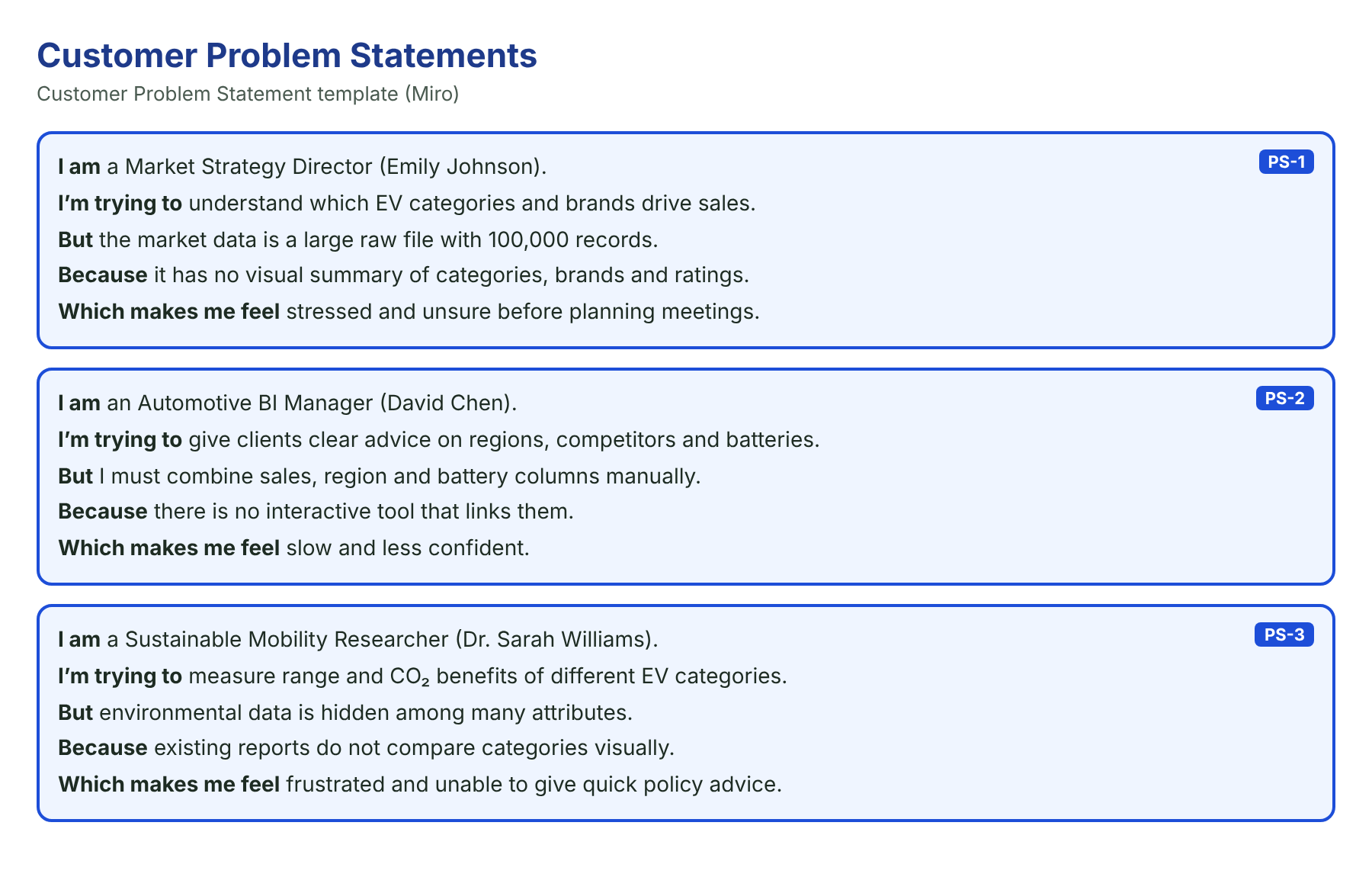
2.2 Empathy Map Canvas
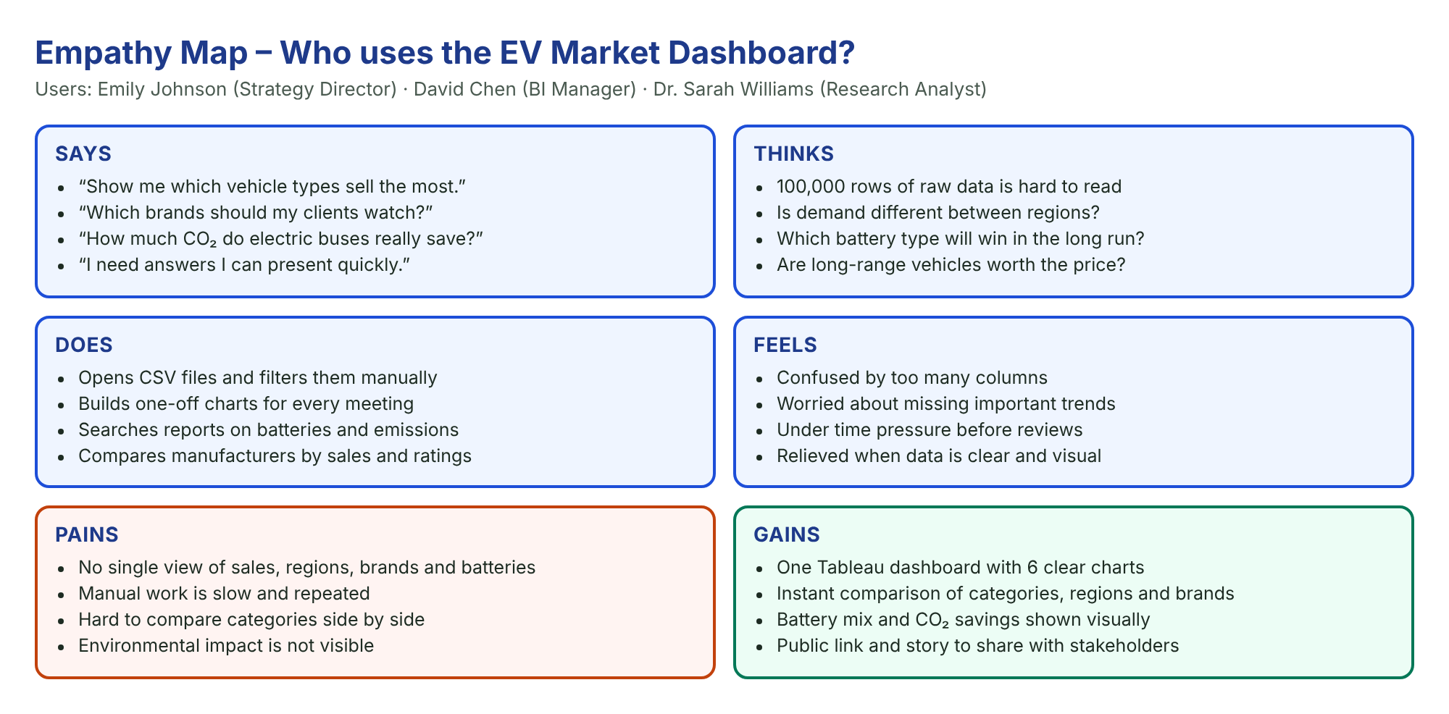
2.3 Brainstorming
Ideas were grouped and ranked by feasibility and importance. A Tableau dashboard for sales, regions and manufacturers, sustainability views (battery, range, CO₂) and a published story were selected; a price prediction model was not selected.
3. REQUIREMENT ANALYSIS
3.1 Customer Journey Map
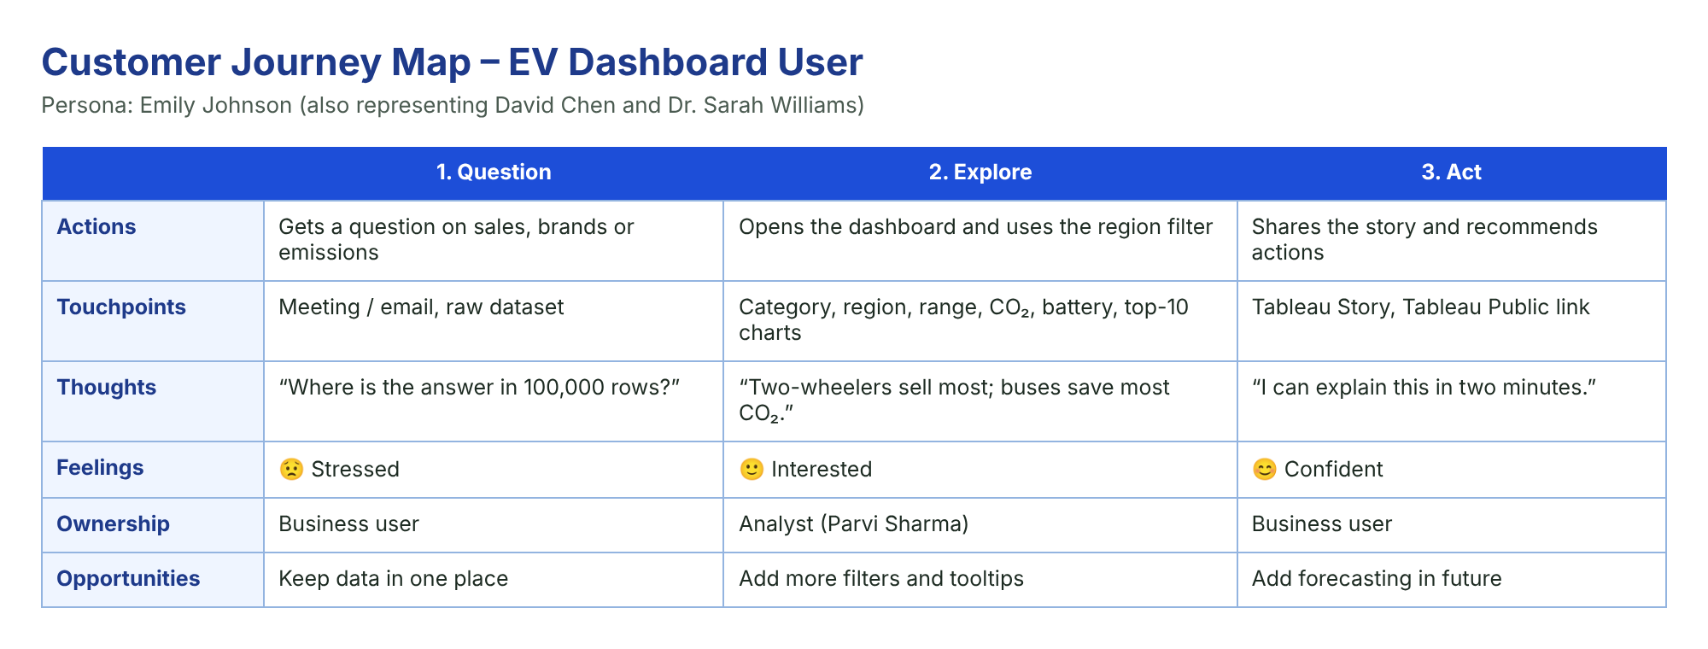
3.2 Solution Requirement
FR | Requirement | Description
FR-1 | Data access | Connect ev_market_test.csv to Tableau as an extract
FR-2 | Data processing | Check types, nulls, duplicates
FR-3 | Analysis | SUM, AVG, COUNT, Top-10 rankings
FR-4 | Outputs | 8 worksheets, dashboard, story
FR-5 | Interaction | Region filter, tooltips, sorting
FR-6 | Reporting | Tableau Public link

3.3 Data Flow Diagram
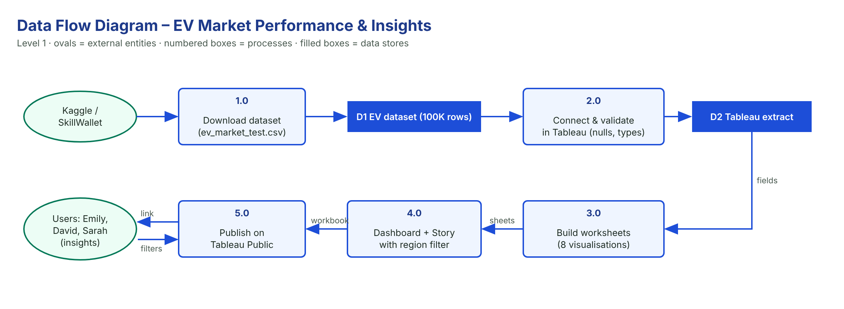
3.4 Technology Stack
Tableau Desktop and Tableau Public (visualisation and publishing), CSV + Tableau extract (data), Tableau calculations (aggregation), GitHub (files and documentation), Google Drive (demo video).
4. PROJECT DESIGN
4.1 Problem Solution Fit
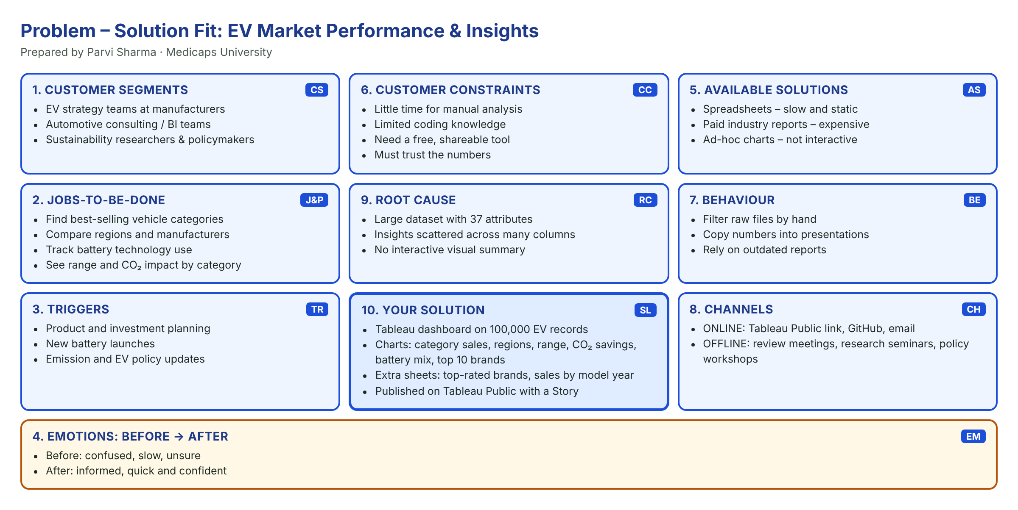
4.2 Proposed Solution
Download the data → check it in Tableau → create an extract → build worksheets → design a dashboard and story → publish on Tableau Public → test and document.
4.3 Solution Architecture

5. PROJECT PLANNING & SCHEDULING
5.1 Project Planning
19 user stories (46 story points) were completed in 4 one-day sprints between 30 October and 3 November 2026; average velocity 11.5 points per sprint.
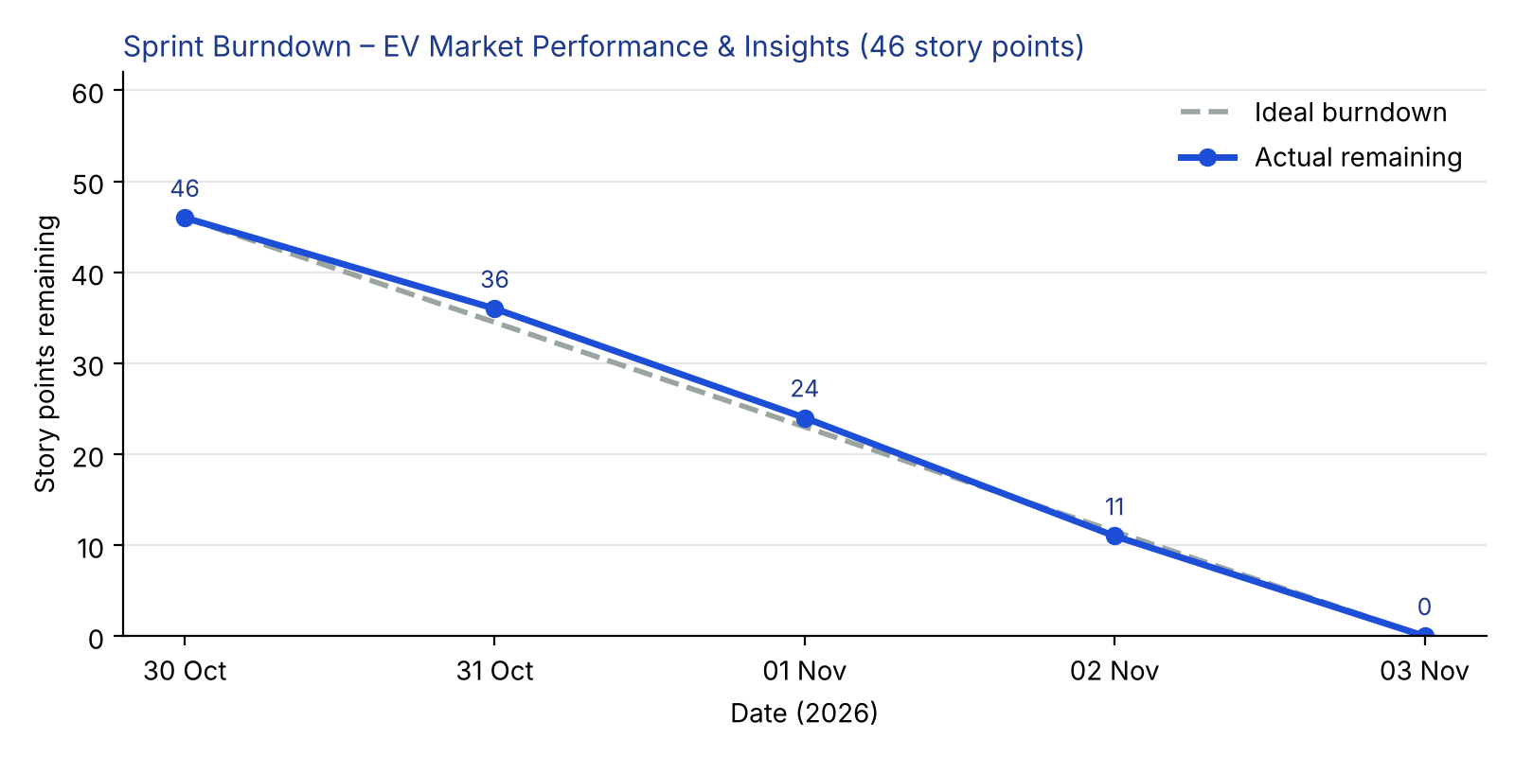
6. FUNCTIONAL AND PERFORMANCE TESTING
6.1 Performance Testing
Parameter | Values
Data Rendered | 100,000 rows × 37 columns in a Tableau extract
Data Checks | 0 duplicates; nulls in 5 columns ignored by SUM/AVG
Filters | Market Region; Top-10 on Manufacturer
Aggregations | SUM([Annual Sales Units]); AVG([Range km]); AVG([CO2 Saved Tons per Year]); COUNT([Vehicle Id]); AVG([Customer Rating])
Dashboard | 6 charts; 8 worksheets in total
Story | 2 story points

7. RESULTS
7.1 Output Screenshots
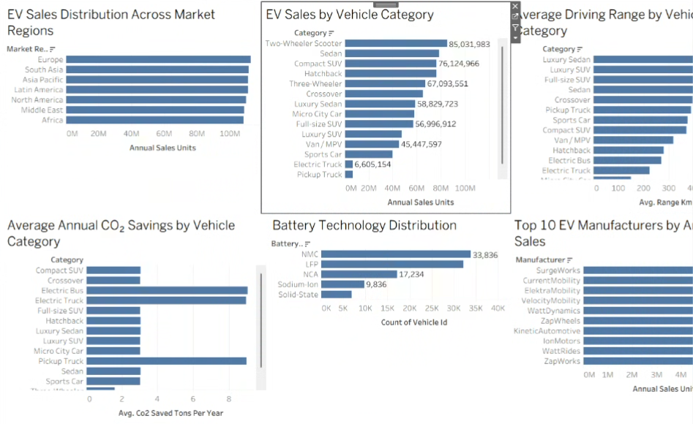
EV Market Dashboard
1. EV Sales by Vehicle Category
Question: Which vehicle categories generate the highest annual EV sales? (Scenario 1, 2)
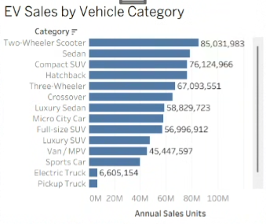
Insight: Two-Wheeler Scooters sell the most (85.0 M units), followed by Sedans (78.3 M), Compact SUVs (76.1 M) and Hatchbacks (76.1 M). Heavy vehicles sell the least – Electric Trucks 6.6 M, Pickup Trucks 6.5 M and Electric Buses 5.3 M.
2. EV Sales Distribution Across Market Regions
Question: How are EV sales spread across the world’s market regions? (Scenario 2)
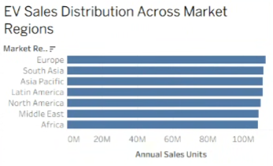
Insight: Sales are very evenly spread: Europe leads with 112.5 M units, followed by South Asia (111.3 M) and Asia Pacific (111.1 M), while Africa is lowest at 108.3 M. Every region holds about 14% of the market, so no single region dominates.
3. Top 10 EV Manufacturers by Annual Sales
Question: Which manufacturers lead the EV market by annual sales? (Scenario 1, 2)
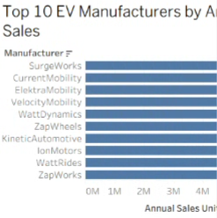
Insight: SurgeWorks leads with 4.88 M units, followed by CurrentMobility (4.78 M) and ElektraMobility (4.75 M). The top 10 brands together hold only about 6% of total sales, showing a highly fragmented, competitive market.
4. Top 10 Manufacturers by Customer Rating
Question: Which manufacturers have the most satisfied customers? (Scenario 1, 2)

Insight: ElektraDynamics has the highest average customer rating (4.17 / 5), followed by ChargeWorks (4.15) and WattMotors (4.14). The overall average is 4.08, so the best brands are only slightly ahead – satisfaction is high across the market.
5. Average Driving Range by Vehicle Category
Question: How does driving range compare across vehicle categories? (Scenario 1, 3)
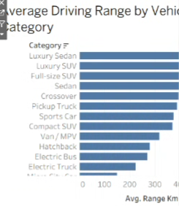
Insight: Luxury Sedans have the longest average range (549 km), then Luxury SUVs (525 km) and Full-size SUVs (476 km). Two-Wheeler Scooters (105 km) and Three-Wheelers (130 km) have the shortest range, matching short urban trips.
6. Battery Technology Distribution
Question: Which battery technologies are most widely used? (Scenario 1, 2, 3)
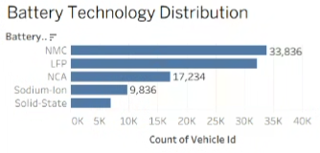
Insight: NMC (33,836 vehicles) and LFP (32,101) are used in about two-thirds of all EVs, followed by NCA (17,234), Sodium-Ion (9,836) and Solid-State (6,993). Solid-State is still an emerging technology.
7. Average Annual CO₂ Savings by Vehicle Category
Question: Which vehicle categories save the most CO₂ every year? (Scenario 3)
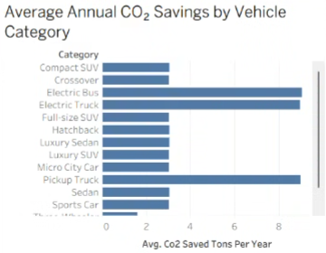
Insight: Electric Buses (9.05 t/yr), Pickup Trucks (9.01) and Electric Trucks (8.96) save about three times more CO₂ per vehicle than passenger cars (≈3.0 t/yr), while two- and three-wheelers save about 1.6 t/yr. Electrifying heavy vehicles gives the biggest environmental benefit.
8. EV Sales by Model Year
Question: How have annual EV sales changed across model years 2018–2026? (Scenario 1, 3)

Insight: Sales stay in a steady band of 82.6 M–88.1 M units per model year. The 2021 models sold the most (88.1 M) and the 2025 models the least (82.6 M), so demand is stable rather than falling.
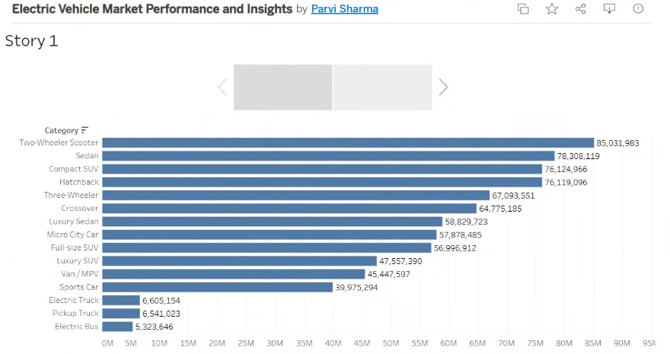
Tableau Story
8. ADVANTAGES & DISADVANTAGES
Advantages
• Answers all three scenarios in one place.
• Easy to read – sorted bar charts with clear titles.
• Free and shareable through Tableau Public.
• Includes environmental impact (CO₂ savings).
Disadvantages
• Static data file, no live refresh.
• Only a region filter on the dashboard.
• No forecasting yet.
9. CONCLUSION
The dashboard shows that affordable urban EVs (two-wheeler scooters, sedans, compact SUVs) drive sales, demand is balanced across all seven regions, no manufacturer dominates (top 10 ≈ 6% of sales), NMC and LFP batteries power about two-thirds of vehicles, luxury vehicles offer the longest range and heavy electric vehicles save the most CO₂. These insights help Emily plan products, David advise clients and Sarah support clean-mobility policy.
10. FUTURE SCOPE
• Add more filters and drill-down.
• Add sales forecasting.
• Connect to live data with scheduled refresh.
• Add price and charging analysis.
11. APPENDIX
Item | Link
Dataset | https://www.kaggle.com/datasets/tharishreddy22/electric-vehicle-market-classification-dataset
Dashboard | https://public.tableau.com/app/profile/parvi.sharma/viz/ElectricVehicleMarketPerformanceandInsights/EVMarketDashboard
Story | https://public.tableau.com/app/profile/parvi.sharma/viz/ElectricVehicleMarketPerformanceandInsights/Story1
GitHub | [Paste GitHub repository link]
Demo video | [Paste Google Drive demo video link]

Data checks performed:
• Used the ev_market_test.csv file from the SkillWallet / Kaggle dataset: 100,000 rows × 37 columns.
• Checked the data in Tableau’s Data Source tab: correct data types for 37 fields; Manufacturing Country set as a geographic field.
• Duplicate check: 0 duplicate rows.
• Null check: a few missing values in Annual Sales Units (989), Customer Rating (1,931), Resale Value (3,057), Battery Cycle Life (2,028) and Screen Size (1,506). Tableau’s SUM and AVG ignore nulls, so no rows had to be removed.
• Created a Tableau extract (.hyper) so the dashboard loads fast and can be published to Tableau Public.

